UNIVERSITY OF THE DISTRICT OF COLUMBIA
COMMUNITY COLLEGE
DIVISION OF NURSING, ALLIED HEALTH, LIFE & PHYSICAL SCIENCES
Practical Nurse (PN) Certificate Application Packet

"Partnering for Excellence in Nursing"

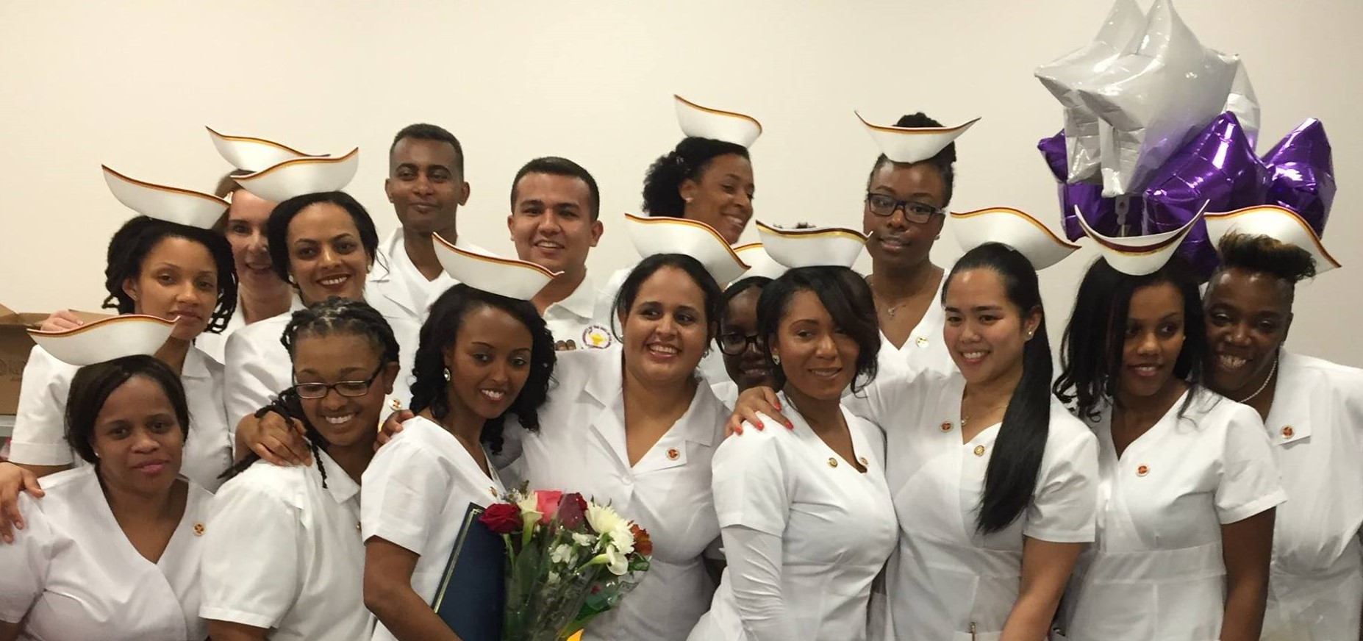

University of the District of Columbia
Community College
Division of Nursing, Allied Health, Life, and Physical Sciences
Practical Nurse (PN) Certificate Program

Nursing Program Guidelines

1. Complete the application by

The application must include the following attachments.
- Attachment 1: Essay
  - In your essay, answer this question: "Why do I want to be a registered nurse and How can I give back?"
  - At the completion of the application, submit your typed essay (as a Word or PDF attachment) to the application.
  - Your essay should be typed, double-spaced on standard-sized white paper (8.5" x 11") with 1" margins on all sides.
  - You should use Times New Roman font or Calibri 12-point font. Your essay length should be one page.
  - Place your signature and the date on the lower right corner of the essay page.
  - If the essay is not attached to the application, the application will not be processed.
- Attachment 2: Official Transcripts
  - Official transcripts from all universities and/or colleges previously attended
  - Do not include pictures of your essay or transcripts.
  - Attach each official transcript from all universities and/colleges previously attended to the application.
  - Submission of your transcripts is located at the end of the application.

2. Two Professional Recommendations
- Two Professional Recommendations must be submitted by the individuals who are making the recommendations.
- The recommendations must be submitted by professional individuals such as a supervisor, professor, assistant manager, or manager.
- Send the link below to the individuals who will submit a recommendation for you. The recommendations must be submitted no later than

3. ATI Admission Assessment for Eligible Applicants (By Invitation ONLY)
- The admission process includes completion of the ATI Admission Assessment.
- Each tester is responsible for paying the ATI Admission Assessment fee of $120.
- Information about the ATI Admission Assessment is available on the program’s website.

4. Background Check for Eligible Applicants (By Invitation ONLY)
- The admission process includes a background check.
- Information about the background check will be sent to each eligible applicant after review of applications.

Helpful Information

1. Application packets take approximately four weeks to process. Therefore, applicants will receive communications from the program after the review process.

2. Each applicant's acceptance or denial status will be communicated via email after applicants have been evaluated. Students who are accepted into the nursing program must submit additional information listed below (after acceptance). However, specific details regarding submission of the items below will be communicated to the applicants who are accepted into the PN Certificate Program.

- Picture identification (driver’s license or passport)
- Current CPR certification for health care providers (American Heart Association - RQI Provided by UDC)
- UDC Student ID
- Health clearance
- Additional documentation required by some health care agencies includes immigration status, police clearance, and drug screening.

Applicants who are not accepted into the Practical Nurse Program must reapply to be considered for future admission cycles. For further information, please contact the main office, at [202] 274-5940.

General Education Requirements

COURSE NO. COURSE TITLE CREDIT HOURS

IGED-120C Foundation Quantitative Reasoning 3 ____
IGED-110C Foundation Writing in Arts & Humanities 3 ____
BIOL-111C Anatomy and Physiology I -Lecture 3 ____
BIOL-113C Anatomy and Physiology I –Lab 1 ____
BIOL-112C Anatomy and Physiology II Lecture 3 ___
BIOL-114C Anatomy and Physiology II Lab 1 ____
FSEM-101C First Year Seminar 1 ____
Total General Education and Science Requirements 15Credit Hours

University of the District of Columbia
Community College
Division of Nursing, Allied Health, Life, and Physical Sciences
Practical Nurse Certificate Program

NURSING APPLICATION ENROLLMENT CATEGORY

DEMOGRAPHIC INFORMATION

Last Name:___________________________________First Name:___________________________Middle Name:_______________

Maiden Name:___________________________ Married [optional] Single [optional]

Student N#_____________________

Address: [Residence]
Number________________Street___________________________________Apartment#_______________

City____________________________________State_________________Zip Code___________________

Telephone number: Daytime_________________________________ Evening____________________________________

Email: _____________________________________________________ Cell___________________________________________

Date of Birth:____________________________________ Age:_____________________ Sex/Gender:__________________

Race/Ethnicity: [check all that apply]: African American Hispanic/Latino Native American/

Alaskan Native Asian/Pacific Islander White Other

Place of Birth: City________________________________ State__________________ Country____________________

EDUCATION
[Please submit copies of L.P.N. License and unofficial transcript with the application]

High School: Dates Attended:___________________________________ Major:__________________________________

Name:_____________________________________Address:_____________________________________________

Date or Expected Date of Graduation/GED: ________________________High school diploma:___________________

Transfer
Institution: Dates Attended: _____________________________________________________________
Name: ____________________________________________Address: _____________________________________

Date or Expected Date of Transfer: _____________________________Major:________________________________

Other College: Dates Attended:____________________________________ Major: _________________________________

Name:___________________________________Address:_______________________________________________

Date or Expected Date of Graduation:_________________________ Degree:_________________________________

Emergency
Contact: Name_______________________________________________Relationship_________________________________

Phone#__________________________________

LPN: YES NO If yes, please complete the following:

Name/Institution: __________________________________ Dates Attended:_________________________ Major:__________________

Address:_________________________________________________________Date/Graduation:______________________________

License#:______________________________________State/DC:______________________Expiration Date: ___________________

WORK HISTORY

Currently Employed: YES NO Full-time Part-time Hours worked weekly:________________

Place of Employment:___________________________________________________________________________________________

Position/Title: _________________________________________________________________________________________________

Description of Duties:___________________________________________________________________________________________

SIGNATURE OF APPLICANT

Signature of Applicant:_________________________________________________________________ Date: __________________

The University of the District of Columbia Community College provides equal opportunity to all persons regardless of race, color, religion, national origin, sex, age, marital status, personal appearance, sexual orientation, family responsibilities, matriculation, physical disability, political affiliation, source of income, or place of residence, in accordance with the provisions of the DC Human Rights Act of 1977 [D.C. Law 2-38].

